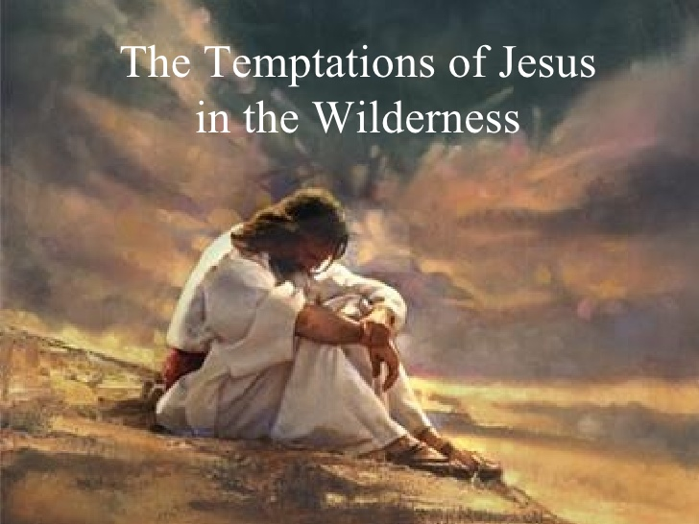
Welcome to
Christ Church!
The First Sunday in Lent
March 10, 2019 at 10:00 a.m.
+ --Appropriate place to make the “Sign of the cross”
BCP—The “Black” Book of Common Prayer
Hymnal—The “Red” Hymnal 1982
LEVAS—Music from Lift Every Voice and Sing Hymnal (Episcopal)
WLP—Music from Wonder, Love, and Praise Hymnal (Episcopal)

Prelude
Processional Hymn “At the Name of Jesus” Hymnal 435

The Great Litany (BCP 148)

O God the Father, Creator of heaven and earth,
Have mercy upon us.

O God the Son, Redeemer of the world,
Have mercy upon us.

O God the Holy Spirit, Sanctifier of the faithful,
Have mercy upon us.

O holy, blessed, and glorious Trinity, one God,
Have mercy upon us.

Remember not, Lord Christ, our offenses, nor the offenses of our forefathers; neither reward us according to our sins. Spare us, good Lord, spare thy people, whom thou hast
redeemed with thy most precious blood, and by thy mercy preserve us, for ever.
Spare us, good Lord.

From all evil and wickedness; from sin; from the crafts and assaults of the devil; and from everlasting damnation,
Good Lord, deliver us.

From all blindness of heart; from pride, vainglory, and hypocrisy; from envy, hatred, and malice; and from all want of charity,
Good Lord, deliver us.

From all inordinate and sinful affections; and from all the deceits of the world, the flesh, and the devil,
Good Lord, deliver us.

From all false doctrine, heresy, and schism; from hardness of heart, and contempt of thy Word and commandment,
Good Lord, deliver us.

From lightning and tempest; from earthquake, fire, and flood; from plague, pestilence, and famine,
Good Lord, deliver us.

From all oppression, conspiracy, and rebellion; from violence, battle, and murder; and from dying suddenly and unprepared,
Good Lord, deliver us.

By the mystery of thy holy Incarnation; by thy holy Nativity and submission to the Law; by thy Baptism, Fasting, and Temptation,
Good Lord, deliver us.

By thine Agony and Bloody Sweat; by thy Cross and Passion; by thy precious Death and Burial; by thy glorious Resurrection and Ascension; and by the Coming of the Holy Ghost,
Good Lord, deliver us.

In all time of our tribulation; in all time of our prosperity; in the hour of death, and in the day of judgment,
Good Lord, deliver us.

We sinners do beseech thee to hear us, O Lord God; and that it may please thee to rule and govern thy holy Church Universal in the right way,
We beesech thee to hear us, good Lord.

That it may please thee to illumine all bishops, priests, and deacons, with true knowledge and understanding of thy Word; and that both by their preaching and living, they may set it forth, and show it accordingly,
We beseech thee to hear us, good Lord.

That it may please thee to bless and keep all thy people,
We beseech thee to hear us, good Lord.

That it may please thee to send forth laborers into thy harvest, and to draw all mankind into thy kingdom,
We beseech thee to hear us, good Lord.

That it may please thee to give to all people increase of grace to hear and receive thy Word, and to bring forth the fruits of the Spirit,
We beseech thee to hear us, good Lord.

That it may please thee to bring into the way of truth all such as have erred, and are deceived,
We beseech thee to hear us, good Lord.

That it may please thee to give us a heart to love and fear thee, and diligently to live after thy commandments,
We beseech thee to hear us, good Lord.

That it may please thee so to rule the hearts of thy servants, the President of the United States, and all others in authority, that they may do justice, and love mercy, and walk in the ways of truth,
We beseech thee to hear us, good Lord.

That it may please thee to make wars to cease in all the world; to give to all nations unity, peace, and concord; and to bestow freedom upon all peoples,
We beseech thee to hear us, good Lord.

That it may please thee to show thy pity upon all prisoners and captives, the homeless and the hungry, and all who are desolate and oppressed,
We beseech thee to hear us, good Lord.

That it may please thee to give and preserve to our use the bountiful fruits of the earth, so that in due time all may enjoy them,
We beseech thee to hear us, good Lord.

That it may please thee to inspire us, in our several callings, to do the work which thou givest us to do with singleness of heart as thy servants, and for the common good,
We beseech thee to hear us, good Lord.

That it may please thee to preserve all who are in danger by reason of their labor or their travel,
We beseech thee to hear us, good Lord.

That it may please thee to preserve, and provide for, all women in childbirth, young children and orphans, the widowed, and all whose homes are broken or torn by strife,
We beseech thee to hear us, good Lord.

That it may please thee to visit the lonely; to strengthen all who suffer in mind, body, and spirit; and to comfort with thy presence those who are failing and infirm,
We beseech thee to hear us, good Lord.

That it may please thee to support, help, and comfort all who are in danger, necessity, and tribulation,
We beseech thee to hear us, good Lord.

That it may please thee to have mercy upon all mankind,
We beseech thee to hear us, good Lord.

That it may please thee to give us true repentance; to forgive us all our sins, negligences, and ignorances; and to endue us with the grace of thy Holy Spirit to amend our lives according to thy holy Word,
We beseech thee to hear us, good Lord.

That it may please thee to forgive our enemies, persecutors, and slanderers, and to turn their hearts,
We beseech thee to hear us, good Lord.

That it may please thee to strengthen such as do stand; to comfort and help the weak-hearted; to raise up those who fall; and finally to beat down Satan under our feet,
We beseech thee to hear us, good Lord.

That it may please thee to grant to all the faithful departed eternal life and peace,
We beseech thee to hear us, good Lord.

That it may please thee to grant that, in the fellowship of all the saints, we may attain to thy heavenly kingdom,
We beseech thee to hear us, good Lord.

Son of God, we beseech thee to hear us.
Son of God, we beseech thee to hear us.

O Lamb of God, that takest away the sins of the world,
Have mercy upon us.

O Lamb of God, that takest away the sins of the world,
Have mercy upon us.

O Lamb of God, that takest away the sins of the world,
Grant us thy peace.

O Christ, hear us.
O Christ, hear us.

Kyrie | S 96
Lord, have mercy upon us. Lord, have mercy upon us. Lord, have mercy upon us.
Christ, have mercy upon us. Christ, have mercy upon us. Christ, have mercy upon us.
Lord, have mercy upon us. Lord, have mercy upon us. Lord, have mercy upon us.

The Collect for the First Sunday in Lent
Celebrant The Lord be with you.
People And also with you.
Celebrant Together, let us pray.

Almighty God, whose blessed Son was led by the Spirit to be tempted by Satan: Come
quickly to help us who are assaulted by many temptations; and, as you know the
weaknesses of each of us, let each one find you mighty to save; through Jesus Christ
your Son our Lord, who lives and reigns with you and the Holy Spirit, one God, now
and for ever. Amen.

The people sit.
The Word of God
First Reading

A reading from the Book of Deuteronomy (26:1-11).

¹When you have come into the land that the Lord your God is giving you as an inheritance to possess, and you possess it, and settle in it, ²you shall take some of the first of all the fruit of the ground, which you harvest from the land that the Lord your God is giving you, and you shall put it in a basket and go to the place that the Lord your God will choose as a dwelling for his name. ³You shall go to the priest who is in office at that time, and say to him, “Today I declare to the Lord your God that I have come into the land that the Lord swore to our ancestors to give us.” ⁴When the priest takes the basket from your hand and sets it down before the altar of the Lord your God, ⁵you shall make this response before the Lord your God: “A wandering Aramean was my ancestor; he went down into Egypt and lived there as an alien, few in number, and there he became a great nation, mighty and populous. ⁶When the Egyptians treated us harshly and afflicted us, by imposing hard labor on us, ⁷we cried to the Lord, the God of our ancestors; the Lord heard our voice and saw our affliction, our toil, and our oppression. ⁸The Lord brought us out of Egypt with a mighty hand and an outstretched arm, with a terrifying display of power, and with signs and wonders; ⁹and he brought us into this place and gave us this land, a land flowing with milk and honey. ¹⁰So now I bring the first of the fruit of the ground that you, O Lord, have given me.” You shall set it down before the Lord your God and bow down before the Lord your God. ¹¹Then you, together with the Levites and the aliens who reside among you, shall celebrate with all the bounty that the Lord your God has given to you and to your house.
Reader The Word of the Lord.
People Thanks be to God.

Psalm 91: 1-2, 9-16

(The Congregation sing the italicized verses. “ / “ –-place to pause for a breath)
¹He who dwells in the shelter of the Most High, *
abides under the shadow of the Al-mighty.
²He shall say to the Lord, / “You are my refuge and my stronghold, *
my God in whom I put my trust.”
⁹Because you have made the Lord your refuge, *
and the Most High your habi-tation,
¹⁰There shall no evil happen to you, *
neither shall any plague come near your dwelling.
¹¹For he shall give his angels charge over you, *
to keep you in all your ways.
¹²They shall bear you in their hands, *
lest you dash your foot against a stone.
¹³You shall tread upon the lion and the adder; *
you shall trample the young lion / and the serpent under your feet.
¹⁴Because he is bound to me in love, / therefore will I de-liver him; *
I will protect him, because he knows my Name.
¹⁵He shall call upon me, / and I will answer him; *
I am with him in trouble; / I will rescue him and bring him to honor.
¹⁶With long life will I satisfy him, *
and show him my sal-vation.

The Epistle

A Reading from Paul’s letter to the church in Rome. (10:8b-13)

^{8b}“The word is near you, on your lips and in your heart” (that is, the word of faith that we proclaim); ⁹because if you confess with your lips that Jesus is Lord and believe in your heart that God raised him from the dead, you will be saved. ¹⁰For one believes with the heart and so is justified, and one confesses with the mouth and so is saved. ¹¹The scripture says, “No one who believes in him will be put to shame.” ¹²For there is no distinction between Jew and Greek; the same Lord is Lord of all and is generous to all who call on him. ¹³For, “Everyone who calls on the name of the Lord shall be saved.” ^{8b}“The word is near you, on your lips and in your heart” (that is, the word of faith that we proclaim); ⁹because if you confess with your lips that Jesus is Lord and believe in your heart that God raised him from the dead, you will be saved. ¹⁰For one believes with the heart and so is justified, and one confesses with the mouth and so is saved. ¹¹The scripture says, “No one who believes in him will be put to shame.” ¹²For there is no distinction between Jew and Greek; the same Lord is Lord of all and is generous to all who call on him. ¹³For, “Everyone who calls on the name of the Lord shall be saved.”

Reader The Word of the Lord.
People Thanks be to God.

The people stand as they are able.

Sequence Hymn “The glory of these forty days” Hymnal 143

The Gospel

Reader The Holy Gospel of our Lord Jesus Christ according to Luke. (4:1-13)
People Glory to you, Lord Christ.

[After his baptism,] ¹Jesus, full of the Holy Spirit, returned from the Jordan and was led by the Spirit in the wilderness, ²where for forty days he was tempted by the devil. He ate nothing at all during those days, and when they were over, he was famished. ³The devil said to him, “If you are the Son of God, command this stone to become a loaf of bread.” ⁴Jesus answered him, “It is written, ‘One does not live by bread alone.’ ”
⁵Then the devil led him up and showed him in an instant all the kingdoms of the world. ⁶And the devil said to him, “To you I will give their glory and all this authority; for it has been given over to me, and I give it to anyone I please. ⁷If you, then, will worship me, it will all be yours.” ⁸Jesus answered him, “It is written, ‘Worship the Lord your God, and serve only him.’ ”
⁹Then the devil took him to Jerusalem, and placed him on the pinnacle of the temple, saying to him, “If you are the Son of God, throw yourself down from here, ¹⁰for it is written, ‘He will command his angels concerning you, to protect you,’ ¹¹and ‘On their hands they will bear you up, so that you will not dash your foot against a stone.’ ”
¹²Jesus answered him, “It is said, ‘Do not put the Lord your God to the test.’ ” ¹³When the devil had finished every test, he departed from him until an opportune time.

Reader The Gospel of the Lord.
People Praise to you, Lord Christ.

Sermon

+ May the words of my mouth and the meditations of all our hearts be always acceptable in your sight, O Lord, our strength and our Redeemer. Amen.
The people sit.

After the Sermon, the people stand as they are able.

The Nicene Creed

We believe in one God, the Father, the Almighty, maker of heaven and earth, of all that is, seen and unseen.

We believe in one Lord, Jesus Christ, the only Son of God, eternally begotten of the Father, God from God, Light from Light, true God from true God, begotten, not made, of one Being with the Father. Through him all things were made. For us and for our salvation he came down from heaven: by the power of the Holy Spirit he became incarnate from the Virgin Mary, and was made man. For our sake he was crucified under Pontius Pilate; he suffered death and was buried. On the third day he rose again in accordance with the Scriptures; he ascended into heaven and is seated at the right hand of the Father. He will come again in glory to judge the living and the dead, and his kingdom will have no end.

We believe in the Holy Spirit, the Lord, the giver of life, who proceeds from the Father and the Son. With the Father and the Son he is worshiped and glorified. He has spoken through the Prophets.

We believe in one holy catholic and apostolic Church. We acknowledge one baptism for the forgiveness of sins. + We look for the resurrection of the dead, and the life of the world to come. Amen.

The Confession

The Celebrant says
Let us confess our sins against God and our neighbor. Silence may be kept.

Celebrant and People

Have mercy upon us, most merciful Father;
in your compassion forgive us our sins,
known and unknown,
things done and left undone;
and so uphold us by your Spirit
that we may live and serve you in newness of life,
to the honor and glory of your Name;
through Jesus Christ our Lord. Amen.

The Absolution

The Priest says
Almighty God have mercy on you, + forgive you all your sins through our Lord Jesus Christ, strengthen you in all goodness, and by the power of the Holy Spirit keep you in
eternal life. Amen.

The Peace

Celebrant The peace of the Lord be always with you.
People And also with you.

The Announcements/Birthday & Anniversary Blessings (BCP 830)

The Presentation of Gifts Hymnal 166 verse 6
The Holy Communion
The Great Thanksgiving—Eucharistic Prayer C (BCP 369)
Celebrant
God of all power, Ruler of the Universe, you are worthy of glory and praise.
Glory to you for ever and ever.

At your command all things came to be: the vast expanse of interstellar space, galaxies, suns, the planets in their courses, and this fragile earth, our island home.
By your will they were created and have their being.

From the primal elements you brought forth the human race, and blessed us with memory, reason, and skill. You made us the rulers of creation. But we turned against you, and betrayed your trust; and we turned against one another.
Have mercy, Lord, for we are sinners in your sight.

Again and again, you called us to return. Through prophets and sages you revealed your righteous Law. And in the fullness of time you sent your only Son, born of a woman, to fulfill your Law, to open for us the way of freedom and peace.
By his blood, he reconciled us. By his wounds, we are healed.

And therefore we praise you, joining with the heavenly chorus, with prophets, apostles, and martyrs, and with all those in every generation who have looked to you in hope, to
proclaim with them your glory, in their unending hymn:

Sanctus S-114

Holy, holy, holy, Lord God of Hosts:
Heaven and earth are full of thy glory.
Glory be to thee, O Lord Most High.
+ Blessed is he that cometh in the name of the Lord.
Hosanna in the highest.

The Celebrant continues
And so, Father, we who have been redeemed by him, and made a new people by water and the Spirit, now bring before you these gifts. Sanctify them by your Holy Spirit to be the Body and Blood of Jesus Christ our Lord.

On the night he was betrayed he took bread, said the blessing, broke the bread, and gave it to his friends, and said, "Take, eat: This is my Body, which is given for you. Do this for the remembrance of me."

After supper, he took the cup of wine, gave thanks, and said, "Drink this, all of you: This is my Blood of the new Covenant, which is shed for you and for many for the forgiveness of sins. Whenever you drink it, do this for the remembrance of me."

Remembering now his work of redemption, and offering to you this sacrifice of thanksgiving,
We celebrate his death and resurrection, as we await the day of his coming.

Lord God of our Fathers and Mothers: God of Abraham and Sarah, Isaac and Rebecca, Jacob, Leah, and Rachel; God and Father of our Lord Jesus Christ: Open our eyes to see your hand at work in the world about us. Deliver us from the presumption of coming to this Table for solace only, and not for strength; for pardon only, and not for renewal. Let the grace of this Holy Communion make us one body, one spirit in Christ, that we may worthily serve the world in his name.
Risen Lord, be known to us in the breaking of the Bread.

Accept these prayers and praises, Father, through Jesus Christ our great High Priest, to whom, with you and the Holy Spirit, your Church gives honor, glory, and worship, from generation to generation.
The Lord’s Prayer
All may join hands with your neighbor as they are comfortable
for the praying of the Lord’s Prayer.

Celebrant And now, as our Savior Christ has taught us, we are bold to say,

People and Celebrant
Our Father, who art in heaven, hallowed be thy Name, thy kingdom come, thy will be done, on earth as it is in heaven. Give us this day our daily bread. And forgive us our trespasses, as we forgive those who trespass against us. And lead us not into temptation, but deliver us from evil. For thine is the kingdom, and the power, and the glory, for ever and ever. Amen.

The Breaking of the Bread

Agnus Dei S-158

O Lamb of God, that takest away the sins of the world,
have mercy upon us.
O Lamb of God, that takest away the sins of the world,
have mercy upon us.
O Lamb of God, that takest away the sins of the world,
grant us thy peace.

The Priest invites the people to Communion
Behold the Lamb of God, behold him who takes away the sins of the world.

Communion Norms--We welcome our guests this morning. All are welcome at the Lord's table. You may stand or kneel (whichever you prefer). You are invited to eat the wafer and then drink from the cup or you may dip the wafer into the cup. The people respond after receiving the bread or the wine by saying "amen." If you prefer not to receive the cup, please cross your arms over your chest. If you do not want to receive communion, you are still welcome to come forward, cross your arms over your chest, and receive a blessing from the priest

Communion Hymn “You who dwell in the shelter of the Lord” WLP 810

The Post Communion Prayer for the First Sunday in Lent
Celebrant Let us pray.

Celebrant and People

God of glory,
You nourish us with your Word
Who is the bread of life:
Fill us with your Holy Spirit
That through us the light of your glory
May shine in all the world.
We ask this in the name of Jesus Christ our Lord. Amen

The Blessing for Epiphany

Grant, Almighty God, that your people may recognize their weakness and put their whole trust in your strength, so that they may rejoice for ever in the protection of your loving providence; and the blessing of God Almighty: + the Father, the Son, and the Holy Spirit be upon you and remain with you always. Amen

Recessional Hymn “Lead us, heavenly Father, lead us” Hymnal 559
The Dismissal
LEM Go in peace to love and serve the Lord.
People Thanks be to God.

Postlude

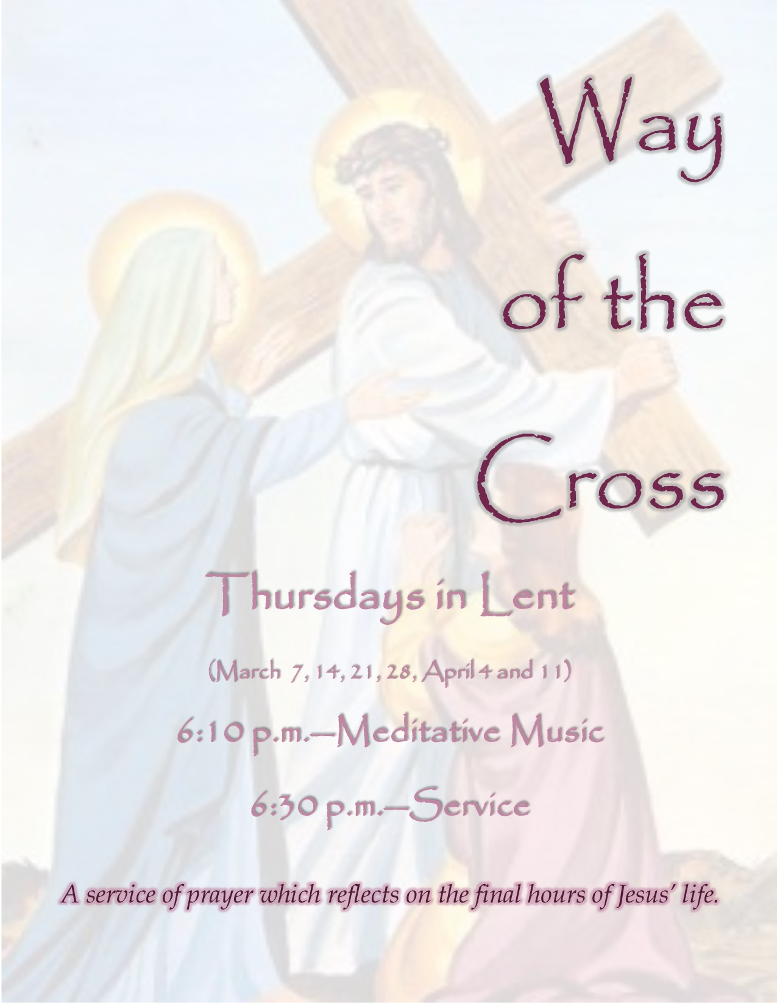
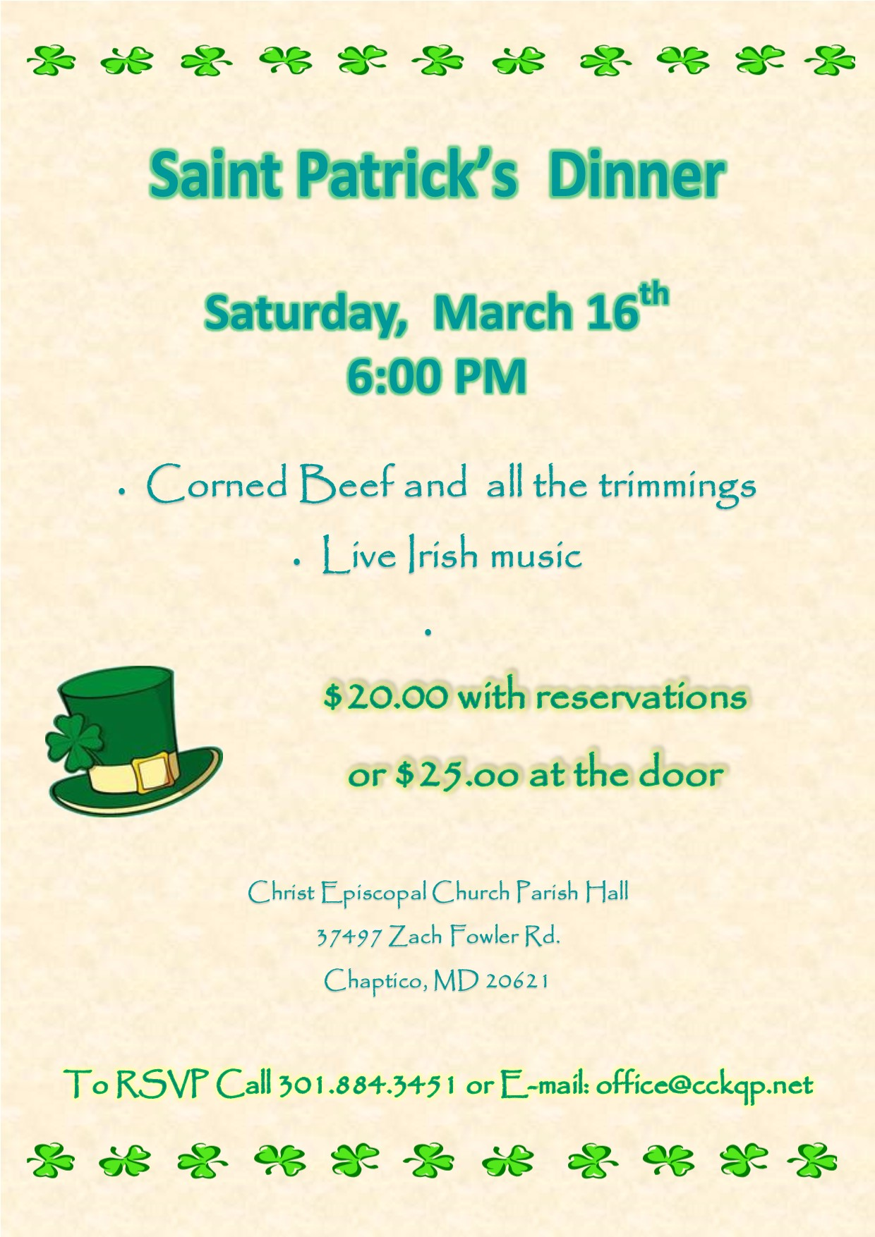
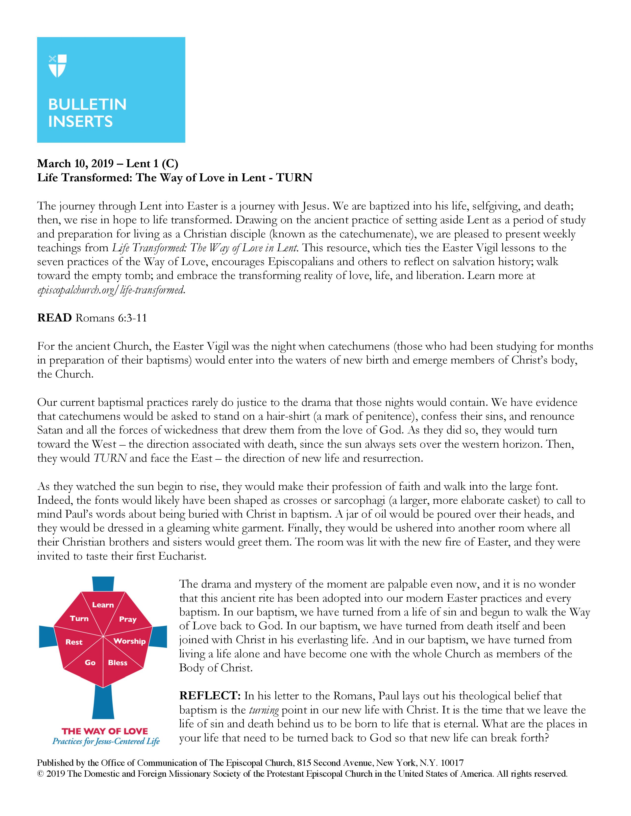

Christ Church
King and Queen Parish
Church: 25390 Maddox Road
Parish Hall: 37497 Zach Fowler Road
P.O. Box 8
Chaptico, MD 20621
Phone: 301.884.3451
E-Mail: office@cckqp.net
www.cckqp.net

Sunday Services
8:00 a.m.—Holy Eucharist (Rite I)—10:00 a.m.—Holy Eucharist (Rite II)

Thursdays
6:10 p.m.—Meditative Music—6:30 p.m.—Simple Holy Eucharist

Office Hours
Tuesday—Friday 9:30 a.m. to 3:30 p.m.
Office closed on Saturday, Sunday, and Monday

The Rt. Rev. Mariann Edgar Budde—Bishop of Washington
The Rev. Christopher D. Jubinski—Rector
Email: frchris@cckqp.net Cell: (410) 253-3664
Mari Rondeau—Parish Administrator
Herb Redmond—Senior Warden
Keith Owens—Junior Warden
Stephen Hunt—Organist
Brad Reeves—Treasurer
Julie Burch--Registrar

Members of the Vestry
Class of 2020: John MacBryde, Herb Redmond, Amy Topolski
Class of 2021: John Harhai, Robert Oppermann, Greg Penk
Class of 2022: Bob Donaldson, Laura Rocheleau, Monty Wright

