Welcome to
Christ Church!
The Fourth Sunday of Easter
“Good Shepherd Sunday”
May 12, 2019 at 10:00 a.m.
+ --Appropriate place to make the “Sign of the cross”
BCP—The “Black” Book of Common Prayer
Hymnal—The “Red” Hymnal 1982
LEVAS—Music from Lift Every Voice and Sing Hymnal (Episcopal)
WLP—Music from Wonder, Love, and Praise Hymnal (Episcopal)
VF—Music from Voices Found Hymnal (Episcopal)

Prelude

God’s People Gather Together

Processional Hymn “The strife is o’er, the battle done” Hymn 208
Celebrant + Alleluia. Christ is risen.
People The Lord is risen indeed. Alleluia.

Celebrant and People
Almighty God, to you all hearts are open, all desires known, and from you no secrets are hid: Cleanse the thoughts of our hearts by the inspiration of your Holy Spirit, that we may perfectly love you, and worthily magnify your holy Name; through Christ our Lord. Amen.

Pascha Nostrum—Christ our Passover (sung to tune Sine Nomine—“For all the saints” WLP 880

The Collect for the Fourth Sunday of Easter

Celebrant The Lord be with you.
People And also with you.
Celebrant Together, let us pray.

O God, whose Son Jesus is the good shepherd of your people: Grant that when we hear his voice we may know him who calls us each by name, and follow where he leads; who, with you and the Holy Spirit, lives and reigns, one God, for ever and ever. Amen.

The people sit.
The Word of God
First Reading
A reading from the Acts of the Apostles (9:36-43)

Now in Joppa there was a disciple whose name was Tabitha, which in Greek is Dorcas. She was devoted to good works and acts of charity. At that time she became ill and died. When they had washed her, they laid her in a room upstairs. Since Lydda was near Joppa, the disciples, who heard that Peter was there, sent two men to him with the request, "Please come to us without delay." So Peter got up and went with them; and when he arrived, they took him to the room upstairs. All the widows stood beside him, weeping and showing tunics and other clothing that Dorcas had made while she was with them. Peter put all of them outside, and then he knelt down and prayed. He turned to the body and said, "Tabitha, get up." Then she opened her eyes, and seeing Peter, she sat up. He gave her his hand and helped her up. Then calling the saints and widows, he showed her to be alive. This became known throughout Joppa, and many believed in the Lord. Meanwhile he stayed in Joppa for some time with a certain Simon, a tanner.

Reader The Word of the Lord.
People Thanks be to God.

Psalm 23 Dominus regit me (Sung at 10:00 a.m. only)

(The Congregation sings the italicized verses. “ / “ –-place to pause for a breath)

1 The Lord is my shepherd; *
I shall not be in want.
2 He makes me lie down in green pastures *
and leads me beside still waters.
3 He revives my soul *
and guides me along right pathways for his Name's sake.
4 Though I walk through the valley of the shadow of death, I shall fear no evil; *
for you are with me;
your rod and your staff, they comfort me.
5 You spread a table before me in the presence of those who trouble me; *
you have anointed my head with oil,
and my cup is running over.
6 Surely your goodness and mercy shall follow me all the days of my life, *
and I will dwell in the house of the Lord for ever.

The Epistle

A reading from the Revelation to St. John (Revelation 7:9-17)

I looked, and there was a great multitude that no one could count, from every nation, from all tribes and peoples and languages, standing before the throne and before the Lamb, robed in white, with palm branches in their hands. They cried out in a loud voice, saying,
“Salvation belongs to our God who is seated on the throne, and to the Lamb!”
And all the angels stood around the throne and around the elders and the four living creatures, and they fell on their faces before the throne and worshiped God, singing,
“Amen! Blessing and glory and wisdom
and thanksgiving and honor
and power and might
be to our God forever and ever!
Amen.”
Then one of the elders addressed me, saying, "Who are these, robed in white, and where have they come from?" I said to him, "Sir, you are the one that knows." Then he said to me, "These are they who have come out of the great ordeal; they have washed their robes and made them white in the blood of the Lamb.
For this reason they are before the throne of God,
and worship him day and night within his temple,
and the one who is seated on the throne will shelter them.
They will hunger no more, and thirst no more;
the sun will not strike them,
nor any scorching heat;
for the Lamb at the center of the throne will be their shepherd,
and he will guide them to springs of the water of life,
and God will wipe away every tear from their eyes."

Reader The Word of the Lord.
People Thanks be to God.

The people stand as they are able.

Sequence Hymn “That Easter day with joy was bright” Hymnal 193

The Gospel John 10:22-30

Reader The Holy Gospel of our Lord Jesus Christ according to John.
People Glory to you, Lord Christ.

At that time the festival of the Dedication took place in Jerusalem. It was winter, and Jesus was walking in the temple, in the portico of Solomon. So the Jews gathered around him and said to him, "How long will you keep us in suspense? If you are the Messiah, tell us plainly." Jesus answered, "I have told you, and you do not believe. The works that I do in my Father's name testify to me; but you do not believe, because you do not belong to my sheep. My sheep hear my voice. I know them, and they follow me. I give them eternal life, and they will never perish. No one will snatch them out of my hand. What my Father has given me is greater than all else, and no one can snatch it out of the Father's hand. The Father and I are one."

Reader The Gospel of the Lord.
People Praise to you, Lord Christ.

The people sit.

The Sermon

+ May the words of my mouth and the meditations of all our hearts be always acceptable in your sight, O Lord, our strength and our Redeemer. Amen.

The people stand as they are able.

The Apostles' Creed

Officiant and People together, all standing

I believe in God, the Father almighty,
creator of heaven and earth;
I believe in Jesus Christ, his only Son, our Lord.
He was conceived by the power of the Holy Spirit
and born of the Virgin Mary.
He suffered under Pontius Pilate,
was crucified, died, and was buried.
He descended to the dead.
On the third day he rose again.
He ascended into heaven,
and is seated at the right hand of the Father.
He will come again to judge the living and the dead.

I believe in the Holy Spirit,
the holy catholic Church,
the communion of saints,
the forgiveness of sins
+ the resurrection of the body,
and the life everlasting. Amen.
Prayers of the People

Celebrant:
Gathered with the living Christ among us, let us offer prayers to God for the needs of all the world, saying: Alleluia! Lord, hear our prayer.

LEM:
For the Church, especially for Justin, the Archbishop of Canterbury; Michael our Presiding Bishop; Mariann and Chilton our Bishops, all the people and parishes of the Diocese of Washington, and for Chris our Priest. We pray that we who have met the risen Christ may be instruments of healing and forgiveness in our broken world. Alleluia! Lord, hear our prayer.

For this parish family, that we may witness to Christ by our deeds and invite others to know Christ through the words we speak. Alleluia! Lord, hear our prayer.

For all who struggle with faith or who lack belief, that God’s presence and love may be made known to them and bring light to their life’s journey. Alleluia! Lord, hear our prayer.

For the people of Sri Lanka, that in their shock and grief they may come to know God's healing and peace in their families and communities. Alleluia! Lord, hear our prayer.

For those who live and work in places of violence and unrest, and for those who struggle for peace and justice, that Christ’s gift of peace may settle in the hearts of all the human family. Alleluia! Lord, hear our prayer.

For all who suffer in body, mind or spirit, remembering especially those on our Prayer List (The people may add petitions for any need or concern). May they encounter the Risen Lord who brings hope and healing, let us pray to the Lord. Alleluia! Lord, hear our prayer.

For those who have died, especially Sean Hailey and Doris Goode. (The people may add petitions either silently or aloud) May they live forever with Christ in the glory of the resurrection, let us pray to the Lord. Alleluia! Lord, hear our prayer.

Lifting our voices with all creation, with Mary the God-bearer and all the saints who have borne witness to the Risen Christ, let us offer ourselves and one another to the living God through Christ. Alleluia! To you, O Lord, we give praise and glory.
All: Blessed are you, Holy God, who gives us the Easter word of peace through Jesus Christ. Hear the prayers which we offer in the hope of glory and breathe upon us with your Holy Spirit. Glory to the holy and undivided Trinity, one God, now and always, and unto the ages of ages. AMEN.

The Peace

Celebrant The peace of the Lord be always with you.
People And also with you.

The Announcements/Birthday & Anniversary Blessings

Offertory Hymn “Now the green blade riseth” Hymnal 204

The Presentation of Gifts
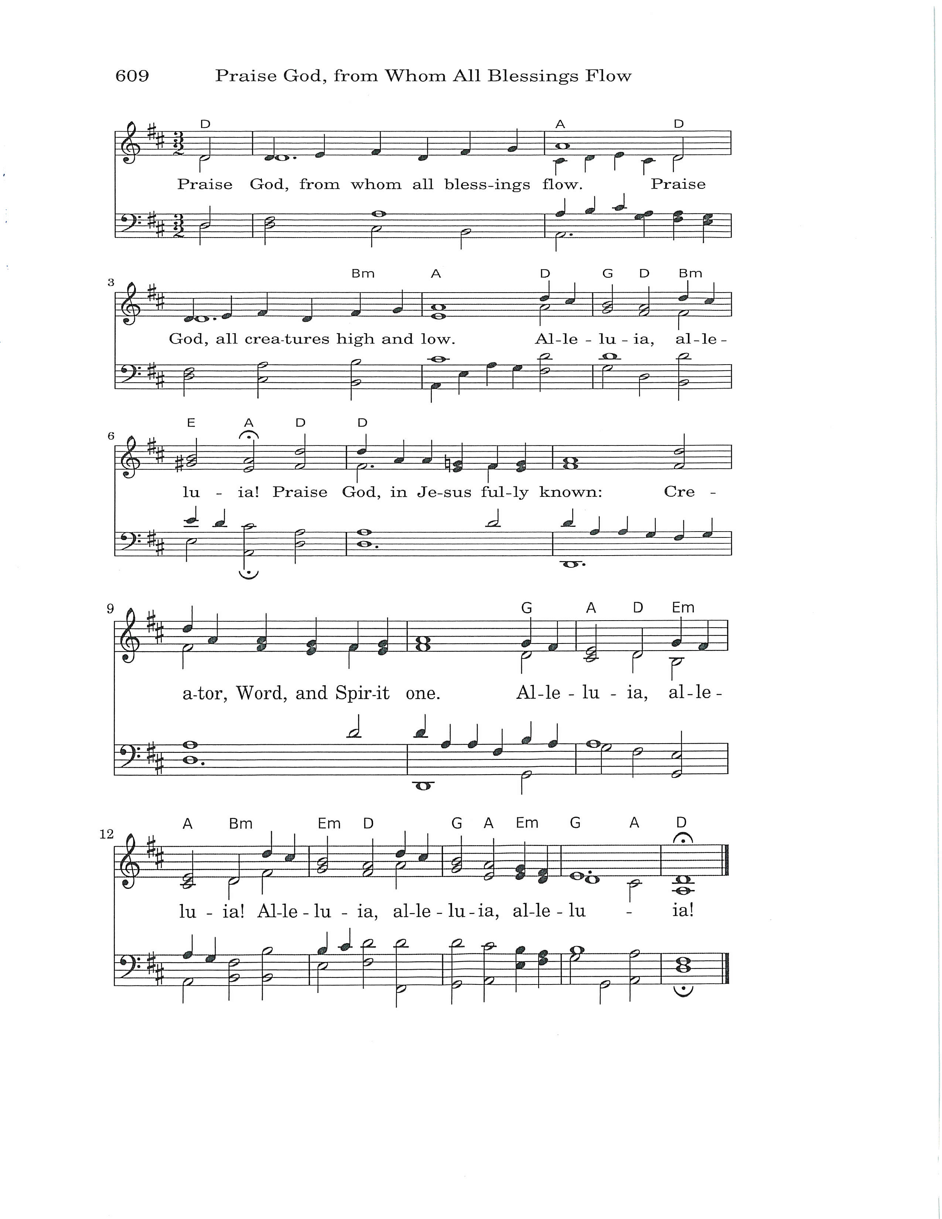
The Holy Communion

The Great Thanksgiving (Eucharistic Prayer A)

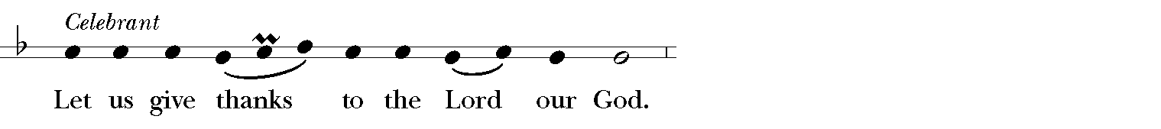
It is right, and a good and joyful thing, always and every where to give thanks to you, Father Almighty, Creator of heaven and earth.

Through Jesus Christ our Lord. But chiefly are we bound to praise you for the glorious resurrection of your Son Jesus Christ our Lord; for he is the true Paschal Lamb, who was sacrificed for us, and has taken away the sin of the world. By his death he has destroyed death, and by his rising to life again he has won for us everlasting life.

Therefore we praise you, joining our voices with Angels and Archangels and with all the company of heaven, who for ever sing this hymn to proclaim the glory of your Name:

Sanctus S-128

Celebrant and People
Holy, Holy, Holy Lord, God of power and might,
heaven and earth are full of your glory.
Hosanna in the highest.
+ Blessed is he who comes in the name of the Lord.
Hosanna in the highest.

The people remain standing

Holy and gracious Father: In your infinite love you made us for yourself, and, when we had fallen into sin and become subject to evil and death, you, in your mercy, sent Jesus Christ, your only and eternal Son, to share our human nature, to live and die as one of us, to reconcile us to you, the God and Father of all. He stretched out his arms upon the cross, and offered himself, in obedience to your will, a perfect sacrifice for the whole world.

On the night he was handed over to suffering and death, our Lord Jesus Christ took bread; and when he had given thanks to you, he broke it, and gave it to his disciples, and said, "Take, eat: This is my Body, which is given for you. Do this for the remembrance of me."

After supper he took the cup of wine; and when he had given thanks, he gave it to them, and said, "Drink this, all of you: This is my Blood of the new Covenant, which is shed for you and for many for the forgiveness of sins. Whenever you drink it, do this for the remembrance of me."

Therefore we proclaim the mystery of faith:

Celebrant and People
Christ has died. Christ is risen. Christ will come again.

The Celebrant continues
We celebrate the memorial of our redemption, O Father, in this sacrifice of praise and thanksgiving. Recalling his death, resurrection, and ascension, we offer you these gifts.

Sanctify them by your Holy Spirit to be for your people the Body and Blood of your Son, the holy food and drink of new and unending life in him. Sanctify us also that we may faithfully receive this holy Sacrament, and serve you in unity, constancy, and peace; and at the last day bring us with all your saints into the joy of your eternal kingdom.

All this we ask through your Son Jesus Christ: By him, and with him, and in him, in the unity of the Holy Spirit all honor and glory is yours, Almighty Father, now and for ever.
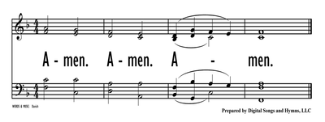

The Lord’s Prayer

Celebrant And now, praying in the words that Jesus taught us,

People and Celebrant
Our Father, who art in heaven, hallowed be thy Name, thy kingdom come, thy will be done, on earth as it is in heaven. Give us this day our daily bread. And forgive us our trespasses, as we forgive those who trespass against us. And lead us not into temptation, but deliver us from evil. For thine is the kingdom, and the power, and the glory, for ever and ever. Amen.

The Breaking of the Bread WLP 876

Communion Norms--We welcome our guests this morning. All are welcome at the Lord's table. You may stand or kneel (whichever you prefer). You are invited to eat the wafer and then drink from the cup or you may dip the wafer into the cup. The people respond after receiving the bread or the wine by saying "amen." If you prefer not to receive the cup, please cross your arms over your chest. If you do not want to receive communion, you are still welcome to come forward, cross your arms over your chest, and receive a blessing from the priest.

Communion Hymn “Just as I am” Hymnal 693
The Post Communion Prayer (Church of England)
Celebrant Let us pray.

Celebrant and People
Father of all,
we give you thanks and praise,
that when we were still far off
you met us in your Son and brought us home.
Dying and living, he declared your love,
gave us grace, and opened the gate of glory.
May we who share Christ’s body live his risen life;
we who drink his cup bring life to others;
we whom the Spirit lights give light to the world.
Keep us firm in the hope you have set before us,
so we and all your children shall be free,
and the whole earth live to praise your name;
through Christ our Lord. Amen.

The Blessing for Eastertide (Church of England)

God the Father, by whose glory Christ was raised from the dead,
strengthen you to walk with him in his risen life;
and the blessing of God Almighty,
+ the Father, the Son, and the Holy Spirit, be with you,
and remain with you always. Amen.

Recessional Hymn “I want to walk as a child of the light” Hymnal 490
The Dismissal

LEM He is not here. He is risen.
Go in peace to love and serve the Lord. Alleluia, alleluia.
People Thanks be to God. Alleluia, alleluia.
Postlude

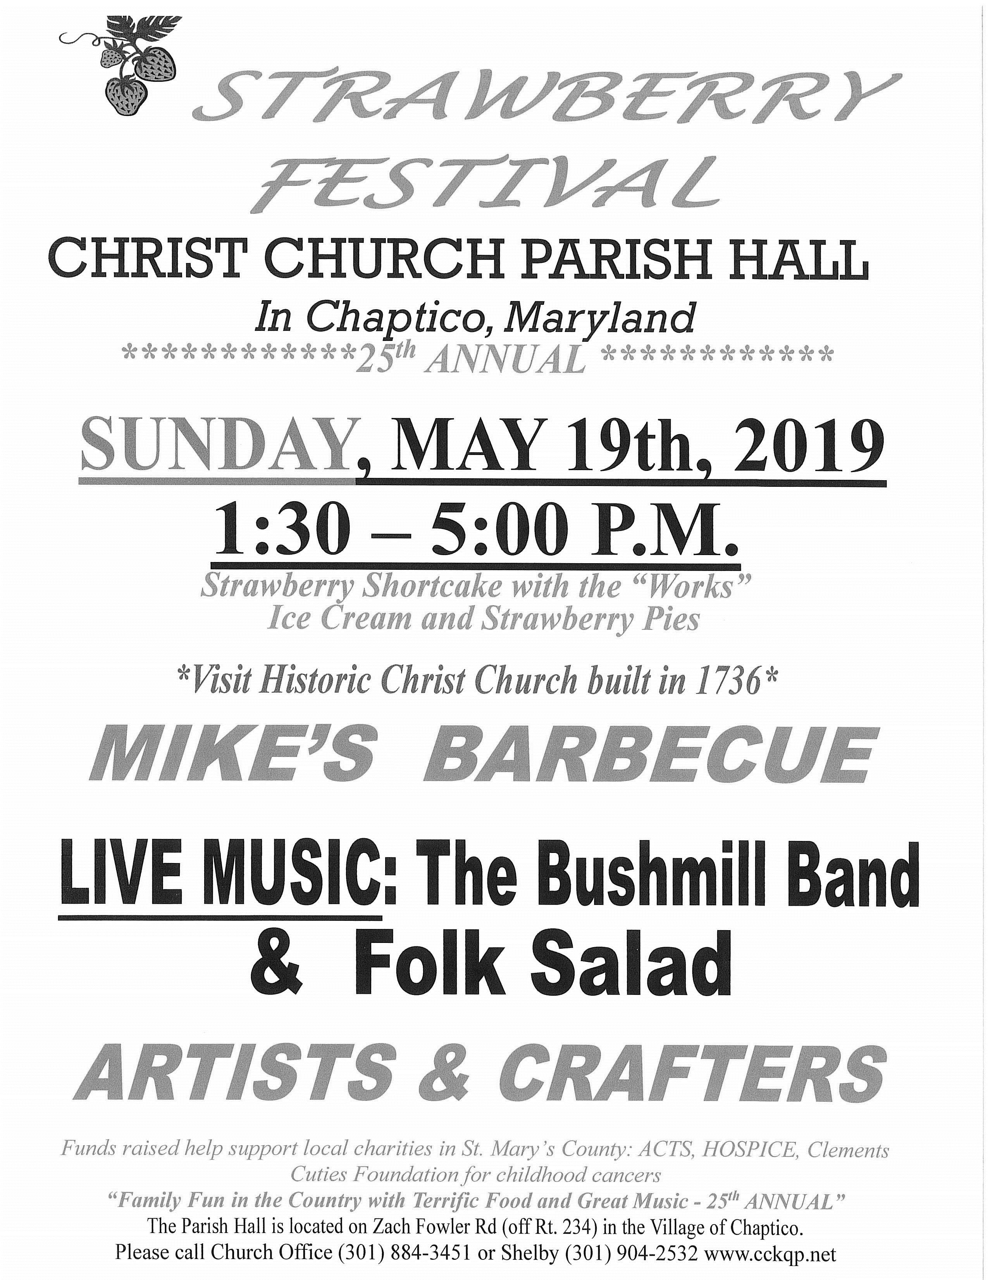
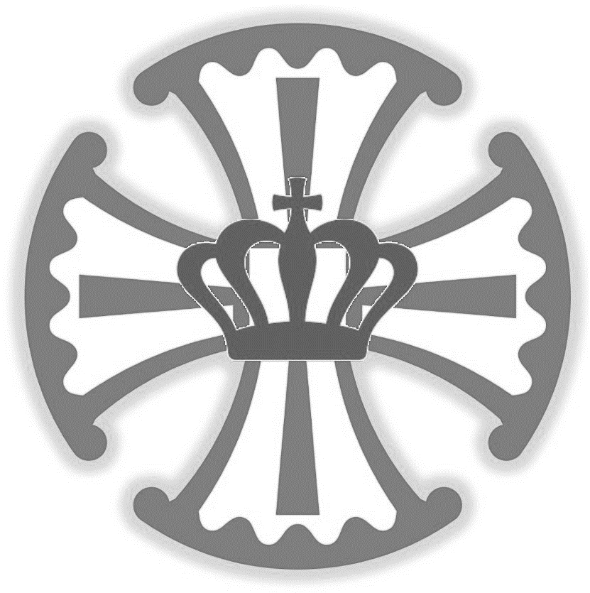

Christ Church
King and Queen Parish
A Parish in the Episcopal Diocese of Washington…Living the Way of Love since 1640.
Church: 25390 Maddox Road
Parish Hall: 37497 Zach Fowler Road
P.O. Box 8
Chaptico, MD 20621
Phone: 301.884.3451
E-Mail: office@cckqp.net
www.cckqp.net

Sunday Services
8:00 a.m.—Holy Eucharist (Rite I)—10:00 a.m.—Holy Eucharist (Rite II)

Thursdays
6:10 p.m.—Meditative Music—6:30 p.m.—Simple Holy Eucharist

Office Hours
Tuesday—Friday 9:30 a.m. to 3:30 p.m.
Office closed on Saturday, Sunday, and Monday

The Rt. Rev. Mariann Edgar Budde—Bishop of Washington

The Rt. Rev. Chilton Knudsen—Assisting Bishop
The Rev. Christopher D. Jubinski—Rector
Email: frchris@cckqp.net Cell: (410) 253-3664
Mari Rondeau—Parish Administrator
Herb Redmond—Senior Warden
Keith Owens—Junior Warden
Stephen Hunt—Organist
Brad Reeves—Treasurer
Julie Burch--Registrar

Members of the Vestry
Class of 2020: John MacBryde, Herb Redmond, Amy Topolski
Class of 2021: John Harhai, Robert Oppermann, Greg Penk
Class of 2022: Bob Donaldson, Laura Rocheleau, Monty Wright

